BCMS PROCEDURE

BUSINESS CONTINUITY PLAN

Date Issued | August 2025
Supersedes Issuance Dated | N/A

Version 1.0
This document supersedes all previous versions.

AMENDMENT HISTORY
REV NO. | DATE | DESCRIPTION
1.0 | 12/08/2025 | Initial Release

1. PURPOSE
The purpose of this procedure is to define the fundamentals of a Business Continuity Plan (BCP) and ensure that the organization can continue to deliver its core products or services to customers in the event of a disruption. The BCP covers all aspects of the organization's operations and functions within the scope of the BCMS.

2. SCOPE
This procedure applies to appropriate activities, products and services within Binance.

3. RESPONSIBILITY
In the event the Business Continuity Plan (BCP) is being activated, BCM Team and relevant employees is to follow the procedures in the BCP.

4. PROCEDURE

4.1 Fundamentals of BCP
4.1.1 Key elements of a BCP will include the following:
- Risk Assessment: Identify potential threats to the organization and the likelihood of them occurring.
- Business Impact Analysis: Determine the potential impact of a disruption on the organization's operations and its ability to deliver products or services to customers.
- Response Plan: Develop a plan to respond to a disruption, including communication strategies, emergency response procedures, and backup systems.
- Recovery Plan: Develop a plan to restore the organization's operations and return to normal business operations as quickly as possible.
- Testing and Maintenance: Test the BCP regularly to ensure it is effective and make updates as necessary to keep it current.
- Training and Awareness: Train employees on the BCP plan and make sure everyone in the organization is aware of their roles and responsibilities in the event of a disruption.

4.2 Scenarios and Assumptions

4.2.1 Business disruptions to Binance’s Business Critical Functions can arise from but not limited to the following scenarios:
- Utilities outage (including power)
- Damage or denial of access to the Office Building (including fire, industrial riot, safety/ security and building collapse).
- IT systems outage/cyberattack
- Supply Chain disruption

4.2.2 BCP in Binance is based on the following key assumptions
- Only critical business functions within the organization BCMS scope will be accorded priority for restoration.
- Should the crisis be projected to exceed seven (7) days, extended planning will commence after day 2 or 3.

4.3 Warning & Communication

4.3.1 At all stages of a crisis, CMT Leader must be consulted before any information pertaining to the crisis is conveyed to external parties, e.g. journalists, vendors, members of the public.

4.3.2 All communication to Public and the media will follow BCPL's protocol and managed by designated staff appointed by Management.

4.3.3 CMT Leader should alert interested parties potentially impacted by an actual or impending disruption prior to activation of BCP.

4.3.4 Internal communication must be made using pre-determined mode of communication detailing information such as the activation of BCP, expectation during disruption & recovery etc.

4.3.5 BCM will maintain open communication with relevant agencies such as Singapore Civil Defence Force (SCDF) in case emergency responders are required.

4.3.7 Details of the disruption, the actions taken and the decisions made during disruption will be documented.

4.4 Corporate Call Tree

4.4.1 During a crisis, the Crisis Management Team (CMT) will activate the following corporate call tree which will subsequently trigger each Representative of Department (ROD) to activate his or her business unit's call tree.

4.4.2 Sequential Flow Chart

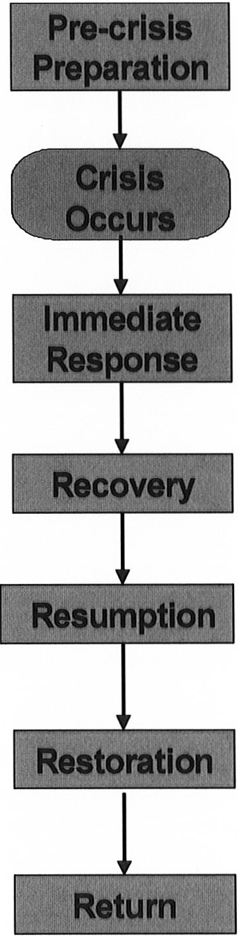
- Update BCP (where necessary)
- Backup critical files

- Occurrence of disruption

- Respond during office hours/ outside office hours
- Assess damage/ reason for denial of access to premise
- Activate departmental recovery plans, if required

- Activate alternative premise
- Activate delivery of equipment, etc
- Occupy alternate site by department

- Restore support functions, data & equipment
- Continue operations at alternative site

- Re-input backlogged and lost data / information
- Implement data synchronization procedures
- Re-commence normal mode of operations

- Return to refurbished or new premise

4.5 Business Unit Call Tree Call Procedures

4.5.1 Instructions
- These procedures are to be used as a guide when notifying staff of a BCP activation
and the action to be taken.

4.5.2 Upon activation, the Representative of Department (ROD) is to proceed and activate the other staff in the business unit call tree.

4.5.3 If person called is available, relay the following information: Disaster status and action to be taken.

4.5.5 If person remains uncontactable for 3 times, call the next person that this person is assigned to notify.

4.5.6 Thereafter, report list of uncontactable persons to your ROD.

4.5.7 ROD will then complete and return the Status Report to the CMT.

4.5.8 Call tree activation to all staff to be completed within 1 hour period.

4.5.9 Business Unit Call Tree
Activation of entire business unit for activation of recovery procedure In your call tree, please indicate the following:
- Name of Staff Members (Initials- to be cross referenced in the recovery procedures later).
- If this person is the Alternate BU Representative, please indicate this below his/her name.
- Indicate the mobile/cellular/hand phone number with an acronym e.g. (M) and home telephone number with (H).
- Highlight in color the staff members who will be going to the alternate premise so that the rest of the staff members will understand that they are required to stay at home during the start of a crisis.
- Indicate if certain staff members need to relocate to another premise.

5. DEFINITIONS

Refer to BCMS Manual (Terms & References)

6. RELATED DOCUMENTS
- BCMS-PRO-08 Incident and Crisis Management

7. RECORDS
- Business Continuity Plan

8. APPENDICES
Nil

